CLASS ACTIVITY:
- Write a program to store 15 integer values in an ArrayList and remove all duplicate elements without using another collection.
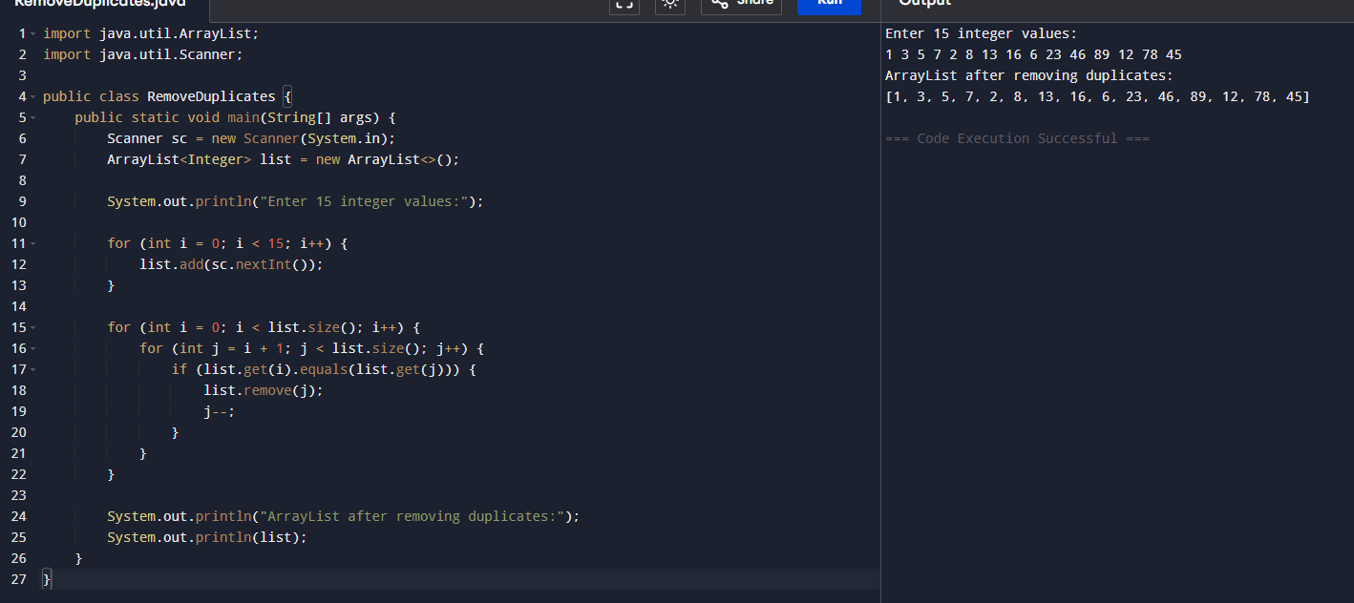
- Store employee IDs in a LinkedList and display them in both forward and reverse order.
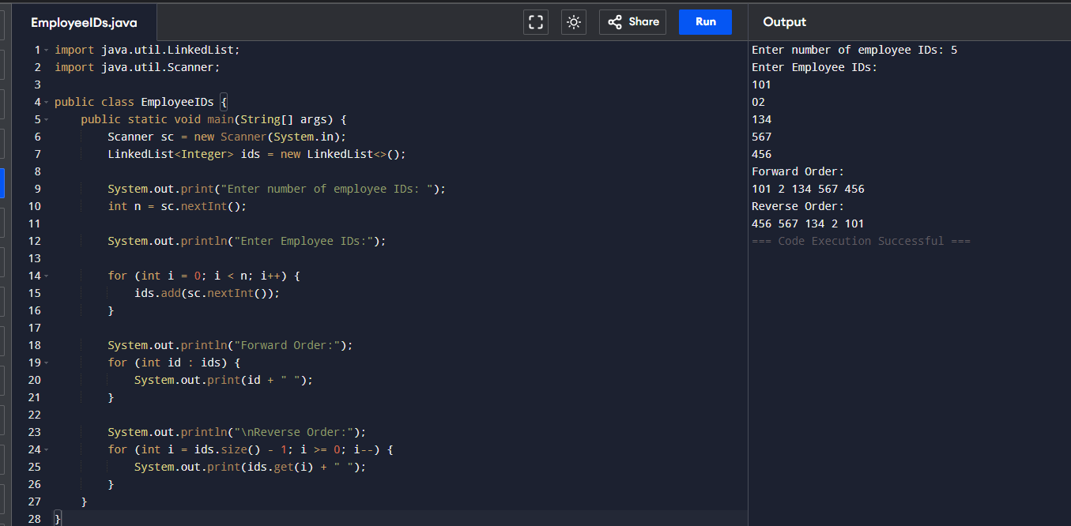
- Store email IDs entered by the user in a HashSet. Display only unique email IDs and count the total unique entries.
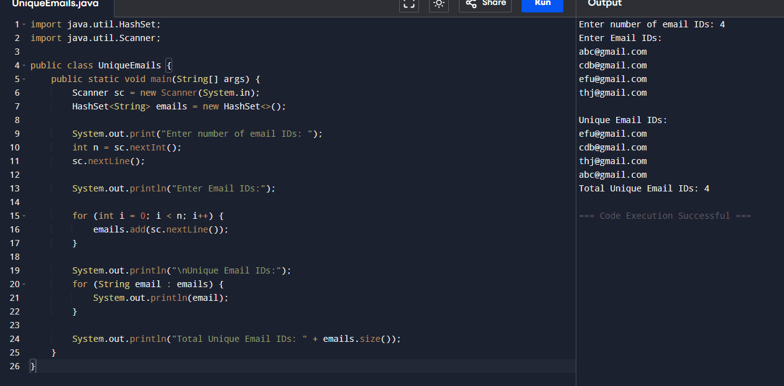
- Write a Java program to count the frequency of each word in a paragraph using a HashMap.
